**Leader Overview**

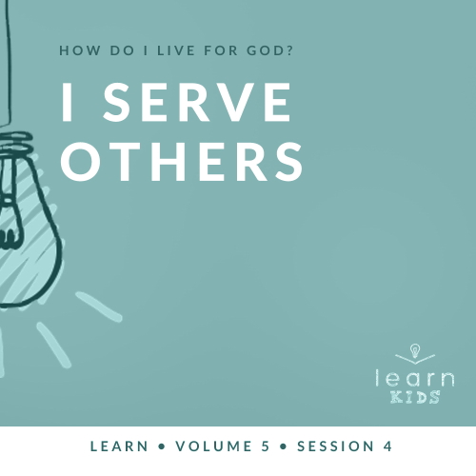

**Volume Overview**

**How do I live for God?**

*As we learn how to live for God, we’ll explore what that looks like in our everyday life. We know the Bible speaks to us, and God wants each of us to live connected to other believers. So, since that’s all true, how do we put God first? How do we get through all the confusion and uncertainty in this world? What does God expect when it comes to giving? How can we show others we care? In these sessions, we’ll consider what the Bible has to say in response to very important questions like these*.

**Session Overview**

**I Serve Others**

*We can’t wholeheartedly live for God if we aren’t willing to serve others. It’s easy in our pursuit of God to ignore those around us, but loving people pleases God. Jesus’ story of the Good Samaritan shows us how to serve. This man loved his neighbor and pleased God by simply serving his neighbor*.

**Bible Lesson**

The Good Samaritan

[Luke 10:30–37](https://ref.ly/logosref/Bible.Lk10.30-37)

**Faith Fact**

I serve others.

**Faith Verse**

[Matthew 6:33](https://ref.ly/logosref/Bible.Mt6.33) (NLT)

“Seek the Kingdom of God above all else, and live righteously, and he will give you everything you need.”

**Preparing for the Session**

**Leader Preparation Time: 20–25 Minutes**

|  |
| --- |
| ***You Will Need***  ***Large Group***   * *Bible* * *Worship songs (Song suggestions: “Chain Reaction” by River Valley Worship; “Only Wanna Sing” by Hillsong Young & Free; “Build My Life” by Passion; “Way Maker” by Leeland)* * *For groups not using a phone or tablet only, add:*   *• Projector or TV*  *• Laptop*  ***• Faith Fact Slide***  ***• Faith Verse Video*** *or* ***Slide***  ***• Bible Lesson Video***  ***• Teaching Point Slides 1–3***  *• Two blindfolds*  *• Ingredients for two BLT sandwiches: bread, tomato slices, head of lettuce,*  *precooked bacon, and mayonnaise*  *• Two plates*  *• Two plastic knives*  *• Plastic tablecloth*  *• Table*  *• Sponge*  *• Bucket or bowl of water*  *• Clear glass or cup*  *• Plate*  *• DVDs with recognizable characters (superheroes, animated films, etc.)*  ***Small Group***   * *Zipper sandwich baggies, one per kid* * *Strips of paper, five per kid* * *Scissors* * *Pens or pencils, one per kid* * *Black permanent marker* * *Bibles for kids in the group to share* * ***Small Group Faith Verse Review****, two per group* * *Two pencils, pens, or markers* * *Table* * ***Small Group Activity Page****, one per kid* * *Pencils or pens, one per kid* * *Markers or crayons*   *To access session content and videos from a computer, visit:* [*BibleEngagementProject.com/downloads*](https://bibleengagementproject.com/downloads) |
|  |

**Large Group**

**30 Minutes**

*See what’s needed at the beginning of the session.*

**Introduction**

Welcome! I’m so glad you’re here. Who has had someone help you out when you faced something difficult? Raise your hand. *(Group response)* I sure have. Who wants to tell us about the last time someone really helped you out in a tough situation? *(Allow responses.)* Those are great examples. Sometimes we really need the help of others around us, especially when life is hard.

**Faith Fact**

Today, we’ll talk about what it looks like to serve others. That’s something God calls us to do when we live for Him. To help us remember, our Faith Fact for today is **I serve others**.

• *Show the* ***Faith Fact Slide***.

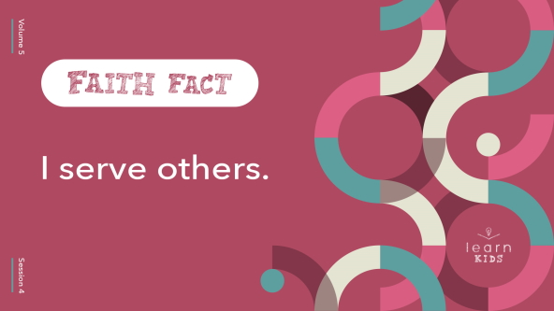

Point to someone and say that with me. **I serve others.** Now point to someone else, and say it again. **I serve others.** It’s great to live for God by helping others in need.

**Game**

**Blindfolded BLT**

|  |
| --- |
| **You Will Need**   * Two blindfolds * Ingredients for two BLT sandwiches: bread, tomato slices, head of lettuce, precooked bacon, and mayonnaise * Two plates * Two plastic knives * Plastic tablecloth * Table   **Getting Ready**   * Set up the two stations at each end of the table. * Set out supplies. * Optional: Leave supplies packaged for an extra challenge. |

Someone often serves us food before we eat. If I were going to serve your favorite sandwich, what would I make for you? Shout it out! *(Group response)* There are some classics like peanut butter and jelly, ham and cheese, and a BLT. BLT stands for bacon, lettuce, and tomato. Today, you ‘ll be competing to see who can make a BLT the fastest—the boys or the girls. Who do you think will win? *(Group response)*

Here’s how it works. I need three boys and three girls to volunteer to help me. One boy and girl will be blindfolded, but their teammates won’t be. The one who’s blindfolded is the only one who can use their hands and make the sandwich. The others can only give instructions. The team must work together to see who can successfully build a BLT first. Don’t forget the mayo. Let’s get started.

• *Give the teams time to make the sandwiches*.

• *Declare the winner. (Note: The sandwiches will likely be messy, so it might be hard to declare a winner. Don’t be afraid to lean into a humorous moment of saying that neither team made the sandwich well enough.)*

That was a lot of fun! To complete this challenging task, each team needed to help the blindfolded person as much as possible because they couldn’t see for themselves. If the teammates didn’t care about helping their friend, then there’s no way they could have completed the sandwich.

**Worship**

Serving others requires us to look beyond ourself and try to help those around us. That includes asking God to help us. Let’s seek God together in worship now.

• *Lead the kids in singing one or two praise songs. See suggestions at the beginning of the session*.

**Bible Lesson**

Thanks for singing and worshipping with me today. Now, let’s get ready to learn from God’s Word. In our Bible story today, Jesus was teaching people about serving others selflessly, no matter who they are. Some people are easy to serve and very thankful. Other times people can be hard to serve. It can be hard to help people who are mean or unappreciative.

In this story, Jesus challenged people to serve others even if they didn’t know them or maybe didn’t even like them. Remember, we can always learn something from God’s Word, so let’s pray and ask God to help us learn from this story today.

**Prayer**

|  |
| --- |
| *Dear God, please help us learn from Your Word today. Help us to see how to serve in a way that honors You and shows others Your love. Amen.* |

**Video Intro**

Before we look at the Bible story, let’s watch this video.

• *Play* ***Bible Lesson Video***.

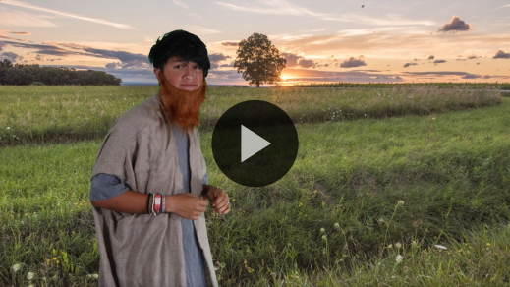

**Bible Story**

**The Good Samaritan**

That was a fun way to get started. Earlier we talked about a time when someone helped you out during a tough situation. That reminds me of our Faith Fact. Say it with me. **I serve others.** What are different kinds of help we can give others to serve them? *(Allow responses.)*

Those are great ideas. In the Bible story, Jesus was teaching people how they should serve others. If you want to follow along, open your Bible or Bible app to [Luke 10:30–37](https://ref.ly/logosref/Bible.Lk10.30-37).

• *Read the Bible story aloud to the group*.

• *In order to keep Large Group time moving along, we don’t recommend having the kids read*.

• *Optional: Remind the kids to mark this place with their Bible Bookmark so they can read it on their own at home*.

**Teaching Time**

|  |
| --- |
| ***You Will Need***   * ***Teaching Point Slides 1–3*** * *Sponge* * *Bucket or bowl of water* * *Clear glass or cup* * *Plate* * *DVDs with recognizable characters (superheroes, animated films, etc.)*   ***Getting Ready***   * *Label the bucket or bowl “God’s Love.” Turn the bucket so the kids can’t see the label.* * *Dip the sponge in the water and set the sponge on the plate with the glass.* |

Wow! How in the world did those first two people completely ignore the injured man on the road? Thankfully, the Samaritan man was willing to help the injured man. The Samaritan man chose to help even though people thought that Jews and Samaritans couldn’t ever get along.

The first two men ignored the injured man, but the Samaritan paid attention to the needs of others. He not only noticed the injured man, but he also went out of his way to help. He pleased God by serving. Serving others requires us to focus less on ourself and more on other people and their needs. Remember, our Faith Fact today is **I serve others**. Let’s say that together one more time. **I serve others**.

**1. We serve because we care**.

• *Show the* ***Teaching Point 1 Slide***.

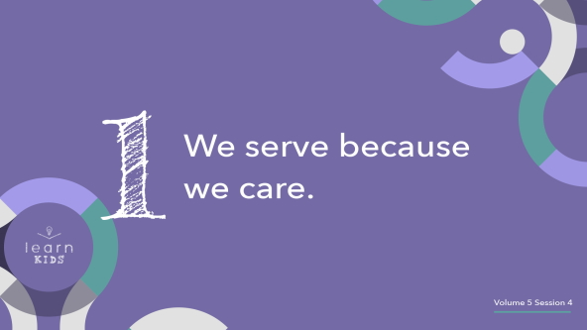

In the BLT game we played earlier, why did the partners help their blindfolded teammate? *(Allow responses.)* They were excited about winning the game, so they were motivated. Every action that we do requires some kind of motivation whether it’s good or bad. When we serve others, we need to be motivated. However, we must also make sure we’re motivated for the right reasons.

God wants us to serve because we care for others. Sometimes we can drag our feet when it comes to doing something we know is right. For example, if your mom or dad asks for help, you may not always feel like doing it. However, we must try our best to serve others with a heart full of compassion. We must care about those who are in need.

Let me show you what that looks like. I need a volunteer to help me.

• *Invite a volunteer to stand next to you*.

• *Hold up the plate with the empty glass and sponge on it*.

When people have a need, it’s like they have a space in their life that needs filled. We’re going to pretend that this empty glass is someone in need like the injured man in our Bible story. The sponge is us. What does our Faith Fact remind us to do? **I serve others.** That’s right. Now, our volunteer is going to take the sponge and squeeze it into the glass. *(Pause while the volunteer does this.)* That’s good. Is there any more water left in the sponge? *(Allow response.)*

When we try to serve on our own, we can be like that sponge. Eventually, we’ll get tired and run out of energy to serve. The good news is that we don’t have to serve on our own. Who can help us? *(Allow responses.)* You’re right. God can.

• *Show the bucket that is labeled God’s Love*.

• *Tell the volunteer to dip the sponge into the bucket and keep filling the glass*.

One way to help us stay motivated to serve for the right reasons is remembering the love God has shown to us. If God didn’t show care and compassion for us, we wouldn’t have the chance to live with Him in heaven one day. Instead, God gave His Son to die for us. He chose to serve us, so we can certainly give to help others. We can love them because God loves us. That’s the best way to show we care for them.

• *Thank the volunteer and have them be seated*.

**2. Serving costs us something**.

• *Show the* ***Teaching Point 2 Slide***.

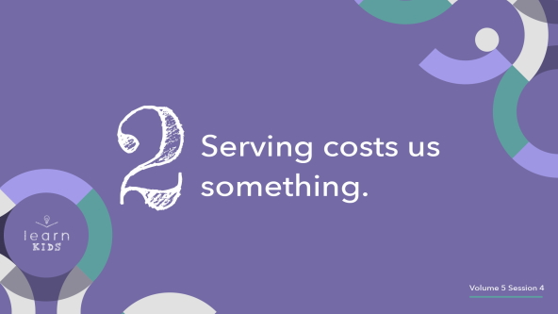

Does anyone here know someone who serves in the military, is a police officer or firefighter, or works in a hospital? *(Allow responses.)* These people have jobs that are focused on serving and helping others.

You may have heard someone say this to them: “Thank you for your service.” People who work in these jobs get thanked for their service because it costs them something. They sacrifice to serve others. They give their time, their energy, and sometimes even their life. When we serve others, we give up something that we have so that someone else can have a need met in their life.

The Samaritan man took his time and spent his money helping the man who had been robbed and beaten. Like him, when we serve others, we give of ourself so that their needs are taken care of. That’s exactly what God did for us. God served us by making a way for us to be with Him in heaven one day. The cost was Jesus giving His life for us.

**3. Serving others shows them Jesus**.

• *Show the* ***Teaching Point 3 Slide***.

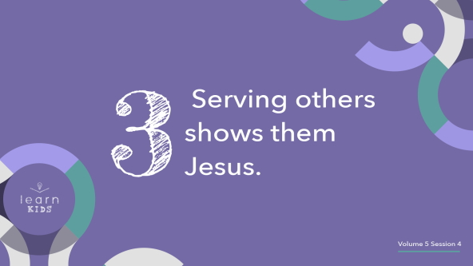

Who is your favorite character from a movie or TV show? Shout it out. *(Allow responses.)* I’ve got some items to show you. When I say, “Go,” shout out the name of your favorite character from it.

• *Hold up the DVDs and see if the kids can name the movie based on the cover of the DVD*.

Have you ever pretended to be your favorite character? *(Group response)* Let’s imagine that we were all playing a game where we were pretending to be superheroes. I decided to be Spider-Man, but I didn’t have a costume. How could you tell that I was Spider-Man? Stand up and show me what I should do. *(Allow responses.)*

Those are great suggestions. If I pretended to have web-slinging hands and swing around on things and climb the walls, you’d be able to tell who I was pretending to me. Lots of superheroes have trademark sayings or actions that make it easy to identify them. Did you know that Jesus was the same way? *(Group response)* When He was here on earth, one of His signature moves was serving others. Just like you could tell I was Spider-Man when I did the web hands, people see who Jesus is through our serving.

Jesus was the most servant-hearted person who ever lived. He said that was one of the main reasons He came to the earth was to serve others. Whether people realize it or not, when we serve others, we’re showing them Jesus. When people meet and understand who Jesus is, He offers to change their heart. If we serve others and show them Jesus’ love, then we get to be a part of making a difference in their life.

**Prayer and Response**

*Consider playing a worship song softly in the background while kids pray*.

We can serve others like the Good Samaritan did. We can serve with our time, money, and many other ways. We just need to ask God to help us know how He wants us to serve and who He wants us to show His love to.

Let’s take some time and ask God what our next step is from today’s lesson. Let’s ask God who we can serve this week and how we can best show them His love. Everyone, bow your head, close your eyes, and let’s ask God to speak to us.

**Prayer**

• *Optional: Have the kids repeat phrases of the prayer after you*.

|  |
| --- |
| Dear God, thank You for teaching us through Your Word how to serve others. Talk to us now about how You want us to serve the people around us—our family, our friends, or even someone we don’t know very well. Help us to show them Your love. Amen. |

Now, just continue to pray and listen for God to speak to you about who you should serve.

• *Pause for a few minutes*.

Is there anyone who’d like to share how they feel God wants them to serve others? *(Allow responses.)*

**Faith Verse**

Our Faith Verse reminds us to keep seeking God, and He will give us what we need. We can continue to do that when it comes to serving others. This is such an awesome encouragement as we look for chances to serve others around us because serving is a way that we can be a part of God’s kingdom.

• *Play* ***Faith Verse Video***.

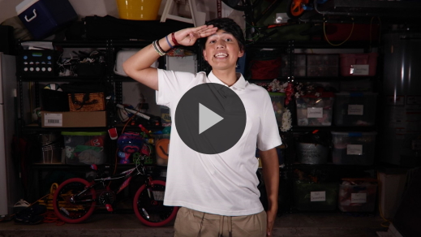

[Matthew 6:33](https://ref.ly/logosref/Bible.Mt6.33) (NLT)

“Seek the Kingdom of God above all else, and live righteously, and he will give you everything you need.”

**Faith Fact**

Before we go to our small groups, let’s review our Faith Fact again.

• *Show the* ***Faith Fact Slide***.



We can serve others. As we do, God will take care of us. Remember our Faith Fact for today. Say it with me. **I serve others.** I know you can do that. It’s been great learning with you today.

• *Dismiss kids to Small Group time or to go home if your group time ends here*.

**Small Group**

**30 Minutes**

*This section can be done in conjunction with the large group or on its own if you do small groups with your kids. During Small Group time, the goal is to connect the kids with the Word of God and to each other. All activities are led by the small group leader.*

**Group Connection**

**“Just Because” Bag**

|  |
| --- |
| ***You Will Need***   * *Zipper sandwich baggies, one per kid* * *Strips of paper, five per kid* * *Scissors* * *Pens or pencils, one per kid* * *Black permanent marker*   ***Getting Ready***   * *Cut strips of paper, five per kid.* |

There are many ways that we can serve others. With a little bit of thought and creativity, we can come up with countless ways to show God’s love to others around us. Let’s brainstorm some ways that we can serve people around us. We’ll take these ideas, write them on strips of paper, and place them in a “Just Because” bag for you to take home.

Let’s start by sharing some of the ways we gave generously to others last week. When we give our time to help others, we are serving them and showing them God’s love. Who would like to share how they helped others?

• *Allow kids to share what they did for their Giving Goals from last time*.

• *As they listen, encourage kids to write down ideas for ways to serve on their slips of papers*.

Now, who has more great ideas of how we can serve others?

• *Help kids think about ways they can serve others. Examples: Help my brother clean his room, bake cookies for a friend or teacher, write an encouraging card for someone, etc*.

• *Write each kid’s name on their bag with the black marker*.

Whenever you want to serve someone, just pull a piece of paper out of your bag. You’ll have your mission to serve ready to go. Watch how your serving will encourage others and share God’s love with them.

**Learn about It**

|  |
| --- |
| ***You Will Need***   * *Bibles for kids in your group to share*   *No prep needed for this activity.* |

**Scripture Search:** [**Matthew 20:26–28**](https://ref.ly/logosref/Bible.Mt20.26-28)**;** [**James 2:14–18**](https://ref.ly/logosref/Bible.Jas2.14-18)**;** [**1 John 3:16–18**](https://ref.ly/logosref/Bible.1Jn3.16-18)**;** [**Luke 6:27–36**](https://ref.ly/logosref/Bible.Lk6.27-36)**;** [**Hebrews 13:1–2**](https://ref.ly/logosref/Bible.Heb13.1-2)

Let’s dig deeper into God’s Word and see what else He has to say about serving. As we find and read each of these verses, let’s consider: What does this Scripture mean for our life today?

• *Give each kid a Bible and search for one or more of the Scriptures as a group together (as time allows). When everyone has found the Scripture, have one of the kids read it. Then, answer the questions about it*.

• *Pair kids who need additional help with older kids or start simple and look up the session’s Bible story Scripture:* [*Luke 10:30–37*](https://ref.ly/logosref/Bible.Lk10.30-37)*. Kids will get better finding Scriptures the more they practice*.

• *Optional: Make this a competition to see who can find the Scripture first*.

**Bible Reading Tip**

God’s Word is so good. It’s important that we spend time reading it since it’s one of the best ways for us to stay close to Him. Sometimes it can be hard to understand what a certain verse means. If you find yourself in that situation, one tip you can try is to pray and ask God to help make clear what He wants you to learn from the passage. Don’t be afraid to try this on verses that are easy to understand. God may want to emphasize a specific part to you, which can make it even more meaningful.

**Challenge**

This week practice asking God what He wants you to focus on when reading a verse that’s important to you. You could even try this with our Faith Verse. Ask God to help you understand what the verse means and to point out what you should focus on.

**Faith Fact**

All our Bible reading is a reminder to me of our Faith Fact. Say it with me: **I serve others**.

**Group Discussion**

*Feel free to use all or just a few questions as a jumping-off place for good discussion. Questions marked with * are designed for more conversation. Adjust the questions based on the age or maturity of your group. Typically, older kids will be able to dive a little deeper than younger ones*.

**Questions**

• *If small group activities are not immediately following large group time, you may want to read the Bible story passage before this discussion*.

Who were the men who didn’t help the injured man?

* Why do you think those men didn’t help the injured man?

Who was the man who helped the injured man?

Why was a Samaritan helping a Jew a big deal in Jesus’ day?

Why do we serve others?

* In what ways does serving cost us something?

* In what ways does serving others show them God’s love?

* What kinds of things keep us from serving others?

* What is a way that you can serve someone this week?

**Prayer Requests**

*Finish group discussion by sharing prayer requests and praise reports. Keep track of your small group’s prayer requests and review them each time you meet*.

**Prayer**

*Have kids pray for each other’s prayer requests*.

**Faith Verse Review**

|  |
| --- |
| ***You Will Need***   * ***Small Group Faith Verse Review Page****, two per group* * *Two pencils, pens, or markers* * *Table*   ***Getting Ready***   * *Print copies of the* ***Small Group******Faith Verse Review Page****, two per group.* |

Our Faith Verse is [Matthew 6:33](https://ref.ly/logosref/Bible.Mt6.33). It tells us that when we seek God’s kingdom and honor God’s ways, He takes care of us. Let’s watch the Faith Verse video and do the actions together.

• *Show* ***Faith Verse Video***.



[Matthew 6:33](https://ref.ly/logosref/Bible.Mt6.33) (NLT)

“Seek the Kingdom of God above all else, and live righteously, and he will give you everything you need.”

**Faith Verse Fun**

**Unscramble It Relay**

Now that we’ve been practicing the Faith Verse for a few weeks, I’ve got an extra challenge for us.

• *Show kids the* ***Small Group******Faith Verse Review Page***.

We’ll divide into two teams to test your speed with our Faith Verse. The words of the verse are scrambled. One at a time, you’ll run to the page and unscramble one of the words by writing it on the line below. Then, you’ll run back and tag the next person on your team. The first team to unscramble the entire verse wins.

* *If you have new or younger kids, encourage those who know the verse well to unscramble the harder or longer words*.

• *Place the* ***Small Group******Faith Verse Review Page*** *on a table across the room to allow for kids to run to it*.

Great job, everyone! This isn’t an easy verse to learn, and you’re doing great.

**Activity Page**

**Serve Like the Samaritan**

|  |
| --- |
| ***You Will Need***   * ***Small Group Activity Page****, one per kid* * *Pencils or pens, one per kid* * *Markers or crayons*   ***Getting Ready***   * *Print copies of the* ***Small Group Activity Page****, one per kid.* |

The story Jesus shared about the Good Samaritan reminds us to serve others. After you color the picture of him and the injured man, add the name of someone who served you and how they helped you. They were like the Good Samaritan to you. When you know who you want to remember, please share with us. Tell us who it is and how they served you.

• *Give kids the* ***Small Group Activity Page****, a pencil, and markers*.

• *Encourage them to share with the group*.

**Dismissal**

Isn’t it wonderful that we can trust that God will lead us in serving others? He wants everyone to know about His love for them as we serve. Let’s close in prayer.

**Prayer**

|  |
| --- |
| *Dear God, thank You for serving us by sending Jesus to give His life for us. Please help us to serve others even if it costs us something. We want to help others like the Good Samaritan did so that we can show Your love to them. Amen.* |

**Faith Fact Recap**

• *Show the* ***Faith Fact Slide***.



There’s something I want you to remember from today, our Faith Fact. Let’s say it together one more time. **I serve others.** I’m glad you came today. I can’t wait to see you next time.

• *Send home the* ***Small Group Activity Page*** *and “Just Because” bags*.

• *Remind parents that there are* ***Family Devotions*** *available on the app to do with their kid*.

• *Tell everyone the date and time for the next session*.